MyCell Protocol: Blood Collection

Introduction

Blood Collection and Infectious Disease Testing
A trained phlebotomist must collect blood samples using Vacutainer tubes supplied in the MyCell Blood Donor Collection Kit.
All blood samples must undergo infectious disease testing (IDT):
- Send all filled vacutainer tubes to CDI within 24 hours.
- The blood must be determined free of HIV, HBV, and HCV.
IDT Name | Relative Current Procedural  Terminology (CPT) Code
Hepatitis B Surface Antigen | 87340
Hepatitis C Antibody | 86803
HIV Antigen and Antibody | 87389
- In the case of a positive result, CDI will discard the donor samples.
All persons collecting and handling any blood samples should be appropriately trained regarding (A) the safe handling and administration of blood and blood components, (B) bloodborne pathogen safety and exposure controls (tasks and procedures to minimize human exposure to such pathogens), and (C) any and all other requirements under all applicable laws and regulations and guidance as to best safety practices.

Required Equipment and Consumables
The following equipment and consumables are required for collecting blood.
Item | Vendor
Equipment
Tabletop Centrifuge with Proper Adaptors for Vacutainer Tubes and Capable of Maintaining 4°C1 | Multiple Vendors
Consumables
MyCell Blood Donor Collection Kit2 | Cellular Dynamics International (CDI)
- CDI recommends using a USA E8 Fixed Speed Centrifuge (LW Scientific, Cat. No. E8C-U8AF-1503) or an equivalent centrifuge
- CDI provides Vacutainer CPT (BD Biosciences, Cat. No. 362761), SST (BD Biosciences, Cat. No. 367977) and Lithium Heparin (BD Biosciences, Cat. No. 367884) tubes in the MyCell Blood Donor Collection Kit.

Workflow
Blood samples are collected in 4 Vacutainer CPT tubes for reprogramming, 1 Vacutainer SST tubes for IDT and in 1 Lithium Heparin tube for DNA extraction.
- Unprocessed fresh blood in CPT, SST and Lithium Heparin tubes are sent to CDI on the same day as blood collection.
IDT

1 x SST Tube

Collect Blood Samples
Reprogramming

4 x CPT Tubes
1 x Li Heparin Tube
Send Fresh Blood
(within 24hr)
to CDI

Note: For clarification on this protocol, request the MyCell Products Webinar: Getting Started by emailing mycell@cellulardynamics.com.

Methods

Collecting Blood Samples
The MyCell Blood Donor Collection Kit includes the Vacutainer CPT, SST and Lithium Heparin tubes for blood samples and MyCell Product labels with CDI-assigned lot numbers for sample identification.
The phlebotomist should collect 4 CPT tubes (8 ml/tube), 1 SST tube (4 ml/tube) and 1 Lithium Heparin tube (4 ml/tube) from each donor.
Note: Store the Vacutainer tubes at room temperature until ready to perform blood collection. Use the Vacutainer tubes within 12 months of the date of manufacture.
- Label the Vacutainer tubes with CDI-provided MyCell Products labels (Figure 1).
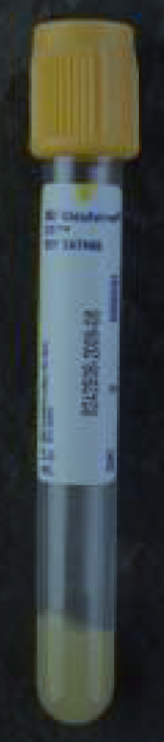 | 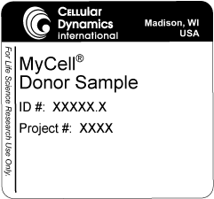 | Figure 1: Labeled Vacutainer Tube  Apply a CDI-provided MyCell Products label to each Vacutainer tube to ensure proper identification.
- Collect the blood samples by venipuncture using standard blood drawing procedures. Immediately invert the SST and CPT tubes 5 times to ensure complete mixing. Invert the Lithium Heparin tubes 8-10 times.
- Incubate the CPT, SST tubes at room temperature for 30 - 120 minutes.
Note: See Appendix A for recommendations on properly handling and processing SST Vacutainer tubes.
- Centrifuge the tubes at room temperature using the speed and duration, as specified below, for the centrifuge’s rotor type:
Note: See the manufacturer’s instructions for adaptors needed to centrifuge Vacutainer tubes.
Note: Ensure the rotor is correctly balanced to achieve proper blood separation.
Note: Lithium Heparin tubes should not be centrifuged
Vacutainer  Tube | Speed (x g) | Duration (min)
 |  | Swinging Bucket Rotor | Fixed Angle Rotor
CPT Tube | 1500 - 1800 | 20 | 10
SST Tube | 1100 - 1300 | 10 | 15
- Inspect the tubes to ensure that proper blood separation was achieved (Figure 2).
Note: If the blood did not separate into phases, ensure the rotor is balanced and centrifuge the tubes once more; however, be aware there will be a reduction in the number of PBMCs isolated. If the blood still does not separate, collect a fresh sample from the same donor.
CPT Tube  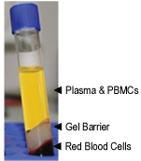 | SST Tube  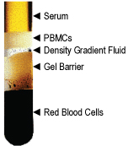 | Figure 2: Vacutainer CPT and SST Tubes after Blood Centrifugation  Blood in CPT and SST tubes separates into phases upon centrifugation.
- Maintain the tubes on ice until ready to package for shipment.
Note: Maintain the tubes on ice until ready to package for shipment. Samples will be maintained on blue ice in gel packs during shipment. See page 3 for detailed shipping instructions.

Sample Shipment
Packaging materials are supplied in the MyCell Blood Donor Collection Kit.

Shipping Fresh Blood
Package fresh blood samples on the same day as blood collection and ship by FedEx for overnight delivery to CDI to ensure arrival at CDI on or before the Thursday of the same week.
- Equilibrate the 2 gel packs at 4°C overnight.
Note: Maintain the gel packs at 4°C until ready to use. Do not freeze the gel packs.
- Place the insulated shipper in the outer shipping box (Figure 3).
- Add a layer of bubble wrap to the bottom of the insulated shipper.
- Wrap the Vacutainer tubes in absorbent paper and place in the small vial carton.
- Place the small vial carton containing the Vacutainer tubes in a sealable plastic bag and then in the insulated shipper.
- Add another layer of bubble wrap and place 2 cold gel packs on top of the bubble wrap before sealing the lid of the shipper.
- Ship by FedEx for overnight delivery using the supplied shipping labels to:
Cellular Dynamics International
c/o AllCells (CDI MyCell 2015 project)
1301 Harbor Bay Parkway, Suite 200,
Alameda, CA 94502
- Send an email with the FedEx tracking number to MyCell2015@allcells.com to enable CDI to track and prepare for delivery of the shipment.
A | B | C | D | E
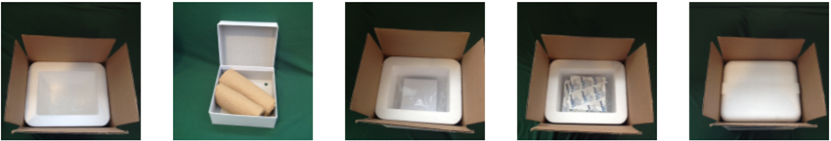
Figure 3: Shipping Vacutainer Tubes Containing Fresh Blood
Package Vacutainer tubes for shipment as follows: (A) Place the insulated shipper with a layer of bubble wrap in the shipping container. (B) Wrap the Vacutainer tubes in absorbent paper and place in the small vial carton. (C) Place the small vial carton in a sealable plastic bag and then in the insulated shipper. (D) Add another layer of bubble wrap followed by 2 gel packs. (E) Seal the lid of the insulated shipper.

Appendices

Appendix A. Proper Handling of Vacutainer Tubes
See the next page for the November 2005 issue of Tech Talk (courtesy of Becton, Dickinson and Company), which details how to handle and process Vacutainer tubes.

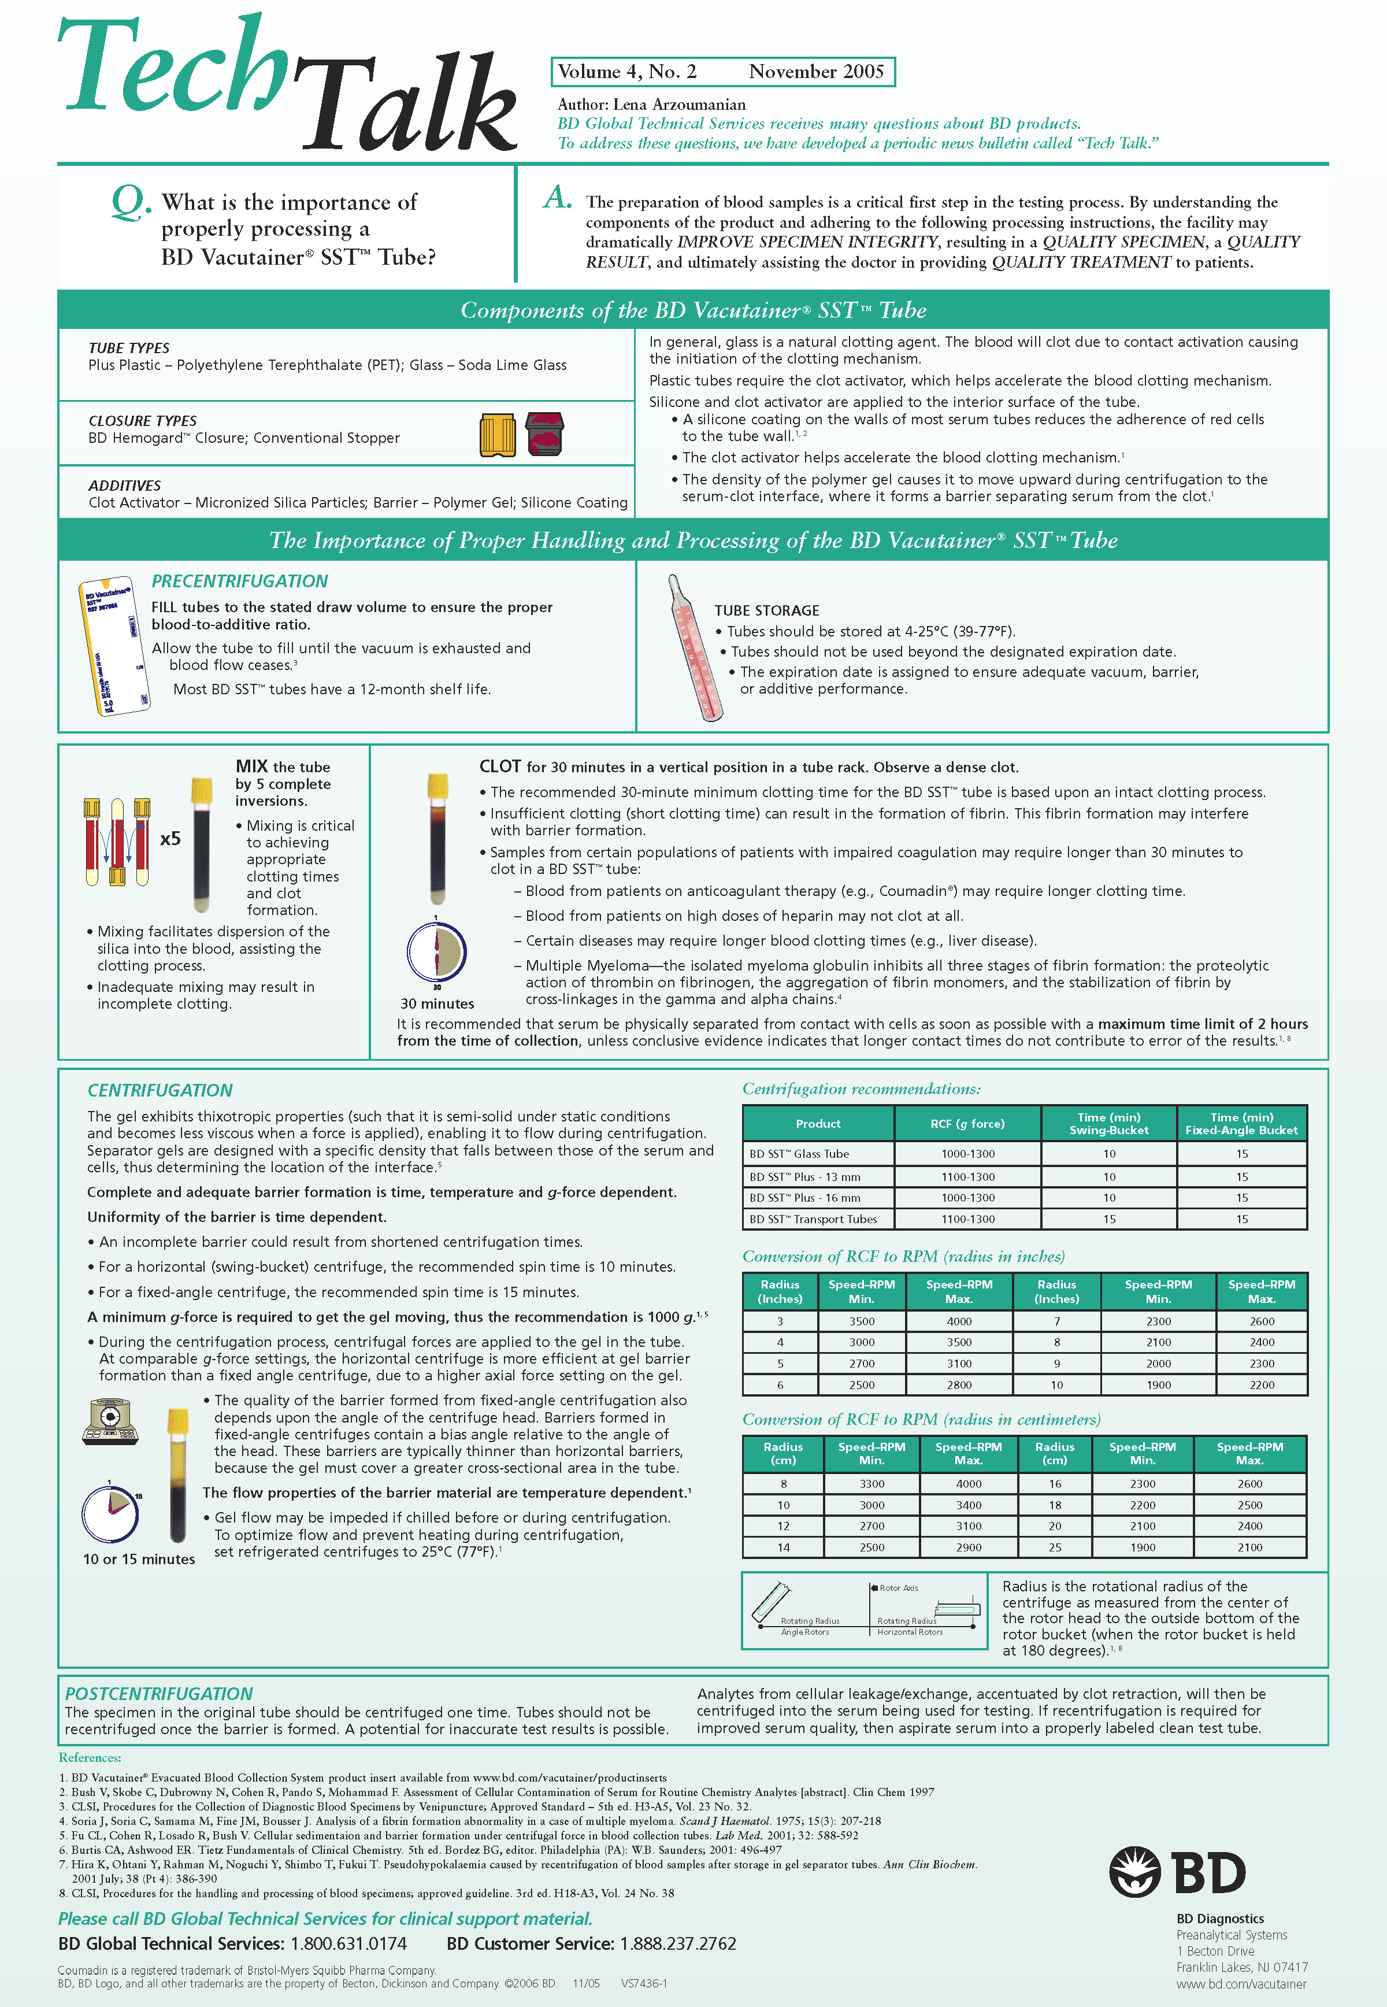

© 2015 Cellular Dynamics International, Inc. All rights reserved.
For Life Science Research Use Only.
iCell and MyCell are registered trademarks, and Cellular Dynamics and the logo are trademarks of Cellular Dynamics International, Inc.
All other brands, product names, company names, trademarks, and service marks are the properties of their respective owners.
Version: April 2015
AP-MPBCP150408

