PPMI Biospecimen PRE-PROPOSAL instructions & application

THE MICHAEL J. FOX FOUNDATION GRANT PORTAL REGISTRATION GUIDE

All pre-proposals must be submitted through the new MJFF Grant Portal.

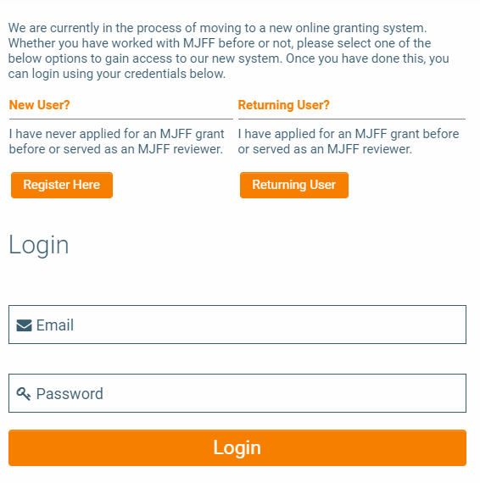

Getting Started: New Users
If you have never applied to an MJFF RFA, click the Register Here button.
- Search for your organization in the Organization Name field. If your organization is not found, click Add New Organization and complete the organization registration.
- Complete the Contact Information fields. Be sure to use an active email address.
- Click the Submit button.
- You will receive an email to the provided email address.
- Follow the instructions in that email to set a password and log in to the Grant Portal.

Getting Started: Returning Users
If you have applied to an MJFF RFA in the past, click the Returning User button.
- Input the email address associated with your MJFF account.
- If the email you entered is in our system, you will receive an email instructing you to reset your password and log in to the Grant Portal.
- If you do not receive an email, you may try a different email address. If you still do not receive an email, please register as a new user.

Once you have logged in to the MJFF Grant Portal, click the Funding Opportunities button to view open funding opportunities. Select PPMI Biospecimen and proceed to start your pre-proposal.

Changing Your Organization
You can access your profile and information by clicking on your initial on the top right of the page and then selecting My Profile. If you notice your organization is incorrect you may request an organization change by following the below steps:

- Navigate to the Organization Change Request tab in your profile.
- Check the Request a Change to Primary Organization or Associated Organization checkbox.
- After reading the instructions on the page and determining your change type, select the appropriate option from the Change Type drop down menu.
- Search for the new organization in the Organization search bar. If it does not currently exist in our database, click the Add Organization if Not Found Above button and follow the steps to register the new organization.
- In the Notes/Description box, please briefly explain the need for the change.
- Click the Request Organization Change button at the bottom of the page.

You can begin an application before the organization change is made. Once you request an organization change, a member of MJFF staff will promptly review your request and send you a confirmation email.

SUBMISSION INSTRUCTIONS

Please review the instructions and requirements below. Please note that proposals will only be accepted through the MJFF Grant portal (https://mjff.smartsimple.com/).

- Following the instructions below, please upload all your application materials to the appropriate fields of the online application.
- Once you begin an online application, you may save and return to it before final submission. You can access it through your portal homepage under Applications in Progress. When ready to submit, please click Submit at the bottom of the application to ensure that your submission is delivered promptly to MJFF.
- A notice of proposal receipt is automatically sent by email upon online submission. If you do not receive this automatic notification within one hour of submission, please contact MJFF at ppmi@michaeljfox.org to check on the status of your proposal.
- All proposals are treated as confidential and will be reviewed by PPMI Biospecimen Review Committee (BRC) and The Michael J. Fox Foundation in collaboration.
- Please refer to the Application Guidelines while preparing your application.
- Please consult PPMI’s Biospecimen Request page and the Biosample Inventory for more information on the number and type of biospecimens available.
- All questions about the application submission should be directed to ppmi@michaeljfox.org.

APPLICATION checklist & proposal instructions

Summary of Application Requirements
- Online Application: Complete the online application tabs with the following information:
  - Project Information & Description tab: Please enter basic information about your proposed project, including title, project duration, and whether this proposal is a resubmission of a previously submitted proposal.
  - Team Information tab: The main applicant will default to the Principal Investigator role on the Research Team Members grid, but this can be changed if necessary. Please fill in required information for the main applicant, including ORCID, and add other members of the team if applicable (including Co-Principal Investigators, Consultants, etc.) For each team member listed, you will need to note their first and last name, institution, position title, email, role on the project, career stage, and ORCID.
  - Attachments tab: Complete the Sample Type Worksheet described below and upload on this tab.
  - Project Proposal Template tab: Complete the Project Proposal Template and Use Agreement, described below, and upload. In the Confirmation section of the Project Proposal Template tab, please confirm your submission and input your initials.
- Documents
  - Sample Type Worksheet: Download the Biospecimen Sample Type Worksheet from the Documents section toward the top of the online application, fill out, and upload in the Sample Type Worksheet field on the Attachments tab. On the Biospecimen Sample Type Worksheet, you will find a different chart for each sample type available: RNA, Plasma, Serum, Whole Blood, Urine, CSF, DNA, and PBMCs (scroll horizontally to view the charts). For each sample type you wish to request, select a Study Arm from the drop down, then select Months from the drop down, then fill in the number of samples you are requesting and the number of aliquots. More information about biosample availability can be found on the PPMI Data website under Biosample Inventory.
  - Project Proposal Template (2 pages maximum not including literature citations page): Using page 5 of this document as a template, combine the following sections as one PDF document and upload in the Pre-Proposal field on the Project Proposal Template tab of the online application. You may delete instructional text, but all narrative headings in the left column must be intact for review. Please refer to the template on page 5 for more information about what each section entails.
- Project background, significance, and rationale
- Samples requested
- Supplemental section for PBMC requests only
- Optional: 1 additional page of figures/supporting data & highly relevant articles referenced in the proposal summary that are published or “in press” at application submission.
  - Use Agreement: Download the Use Agreement from the Documents section toward the top of the online application, fill out, and upload in the Use Agreement field on the Project Proposal Template tab.

PPMI Biospecimen project proposal template (pre-proposal stage)

Application INFORMATION

PRINCIPAL INVESTIGATOR Click here to enter text. EMAIL Click here to enter text.
INSTITUTION Click here to enter text.
PROJECT TITLE Click here to enter text.

Do you plan to seek funding from MJFF for this study? ☐ Yes ☐ No

General FORMATTING GUIDELINES
- Use letter-size pages (8.5 x 11 inches), minimum 11-point font
- Minimum of one-inch margins on the top, bottom, and both sides of every page

Please use the following template to provide more information about your request and upload as one PDF (maximum 2 pages) to the Pre-Proposal field on the Project Proposal Template tab of the online application. Figures, supporting data, and citations of relevant primary literature supporting the proposal are encouraged and do not count against the 2-page limit. You may delete instructional text, but all narrative headings in the left column must be intact for review.

PROJECT BACKGROUND, SIGNIFICANCE, AND RATIONALE | Note: background on Parkinson’s Disease should not be included. Briefly outline the project plan and its significance. PPMI is a study ideally reserved for verification of progression biomarkers and not for biomarker assay development or discovery of novel biomarkers. As such, include pertinent information demonstrating that the proposed biomarker assay(s) are fully optimized for the requested biospecimens under PPMI’s collection protocol. In addition, provide compelling rationale and associated data that indicate that the biomarker(s) has the potential to track PD progression (e.g., correlation with disease severity or duration).
SAMPLES REQUESTED | Provide a justification for the number and type of samples requested (including visit number, subject type, any specific clinical parameters, etc.). Include power calculations to justify the sample numbers.
SUPPLEMENTAL SECTION FOR PBMC REQUESTS ONLY | Please review PPMI’s PBMC collection and processing protocol here. Include the following details in your application: 1) Was the preliminary data provided in this application generated using PBMCs collected and processed using the PPMI protocol? If not, 2) did you use fresh or frozen PBMCs? 3) What starting volume of blood do you need for isolation of PBMCs at the desired cell density for your assay(s)? 4) Please append your PBMC isolation protocol as a supporting document.

